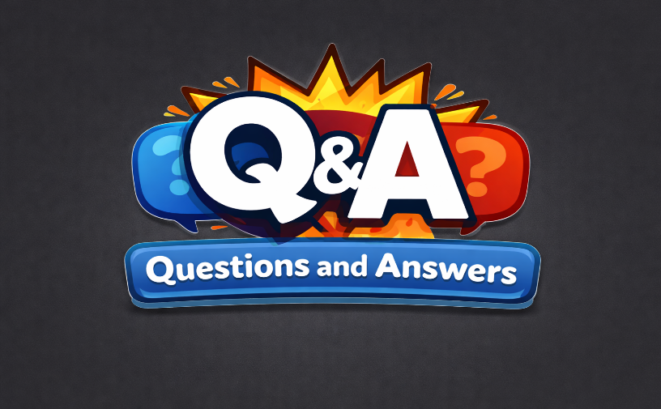
Company: HCL
Role Administrator
1.⁠ ⁠Introduce yourself.
Hello, I’m [Your Name], a ServiceNow developer with over 3 years of experience in designing, developing, and implementing enterprise-level ServiceNow solutions.
I specialize in IT Service Management, HR Service Delivery, and IT Operations Management modules.
I have strong expertise in scripting (JavaScript), configuring Business Rules, Client Scripts, UI Policies, and developing custom applications and workflows.
I have hands-on experience with Update Sets, Transform Maps, integrations, and automation to optimize business processes and improve operational efficiency.
I’m passionate about delivering scalable and user-centric solutions that drive digital transformation and enhance organizational productivity.

2.⁠ ⁠Do you have experience in integrations?
“Yes, I have hands-on experience with ServiceNow integrations. I have worked on integrating ServiceNow with third-party systems using REST and SOAP APIs, web services, and inbound/outbound integrations. This includes data exchange between ServiceNow and external applications, automating workflows, and ensuring seamless communication across systems to optimize business processes.”
3.⁠ ⁠What is inbound and outbound integration?
In ServiceNow, Inbound and Outbound Integrations describe the direction of data flow between ServiceNow and other systems.
🔹 1️⃣ Inbound Integration (Data COMING INTO ServiceNow)
👉 External system → ServiceNow
Definition:
An Inbound Integration is when another system sends data to ServiceNow, and ServiceNow receives, processes, and stores it.
Simple Example:
- Monitoring tool creates an Incident in ServiceNow
- HR system sends employee data to ServiceNow
- Another ServiceNow instance sends records to your instance
How it works in ServiceNow:
- Scripted REST API
- Import Set API
- SOAP API
- Inbound Email Actions
- MID Server (from internal systems)
Example Scenario:
🔹 A meeting tool sends meeting details to ServiceNow
🔹 ServiceNow receives the request
🔹 ServiceNow creates/updates meeting records
Real-life Analogy:
📬 Receiving a courier at your home

🔹 2️⃣ Outbound Integration (Data GOING OUT of ServiceNow)
👉 ServiceNow → External system
Definition:
An Outbound Integration is when ServiceNow sends data to another system.
Simple Example:
- ServiceNow sends incident data to Jira
- ServiceNow sends meeting details to MS Teams
- ServiceNow pushes data to another ServiceNow instance
How it works in ServiceNow:
- REST Message
- SOAP Message
- Business Rules
- Flow Designer
- Scheduled Jobs
- MID Server
Example Scenario:
🔹 Meeting record created in ServiceNow
🔹 ServiceNow sends data to calendar system
Real-life Analogy:
📤 Sending a courier from your home
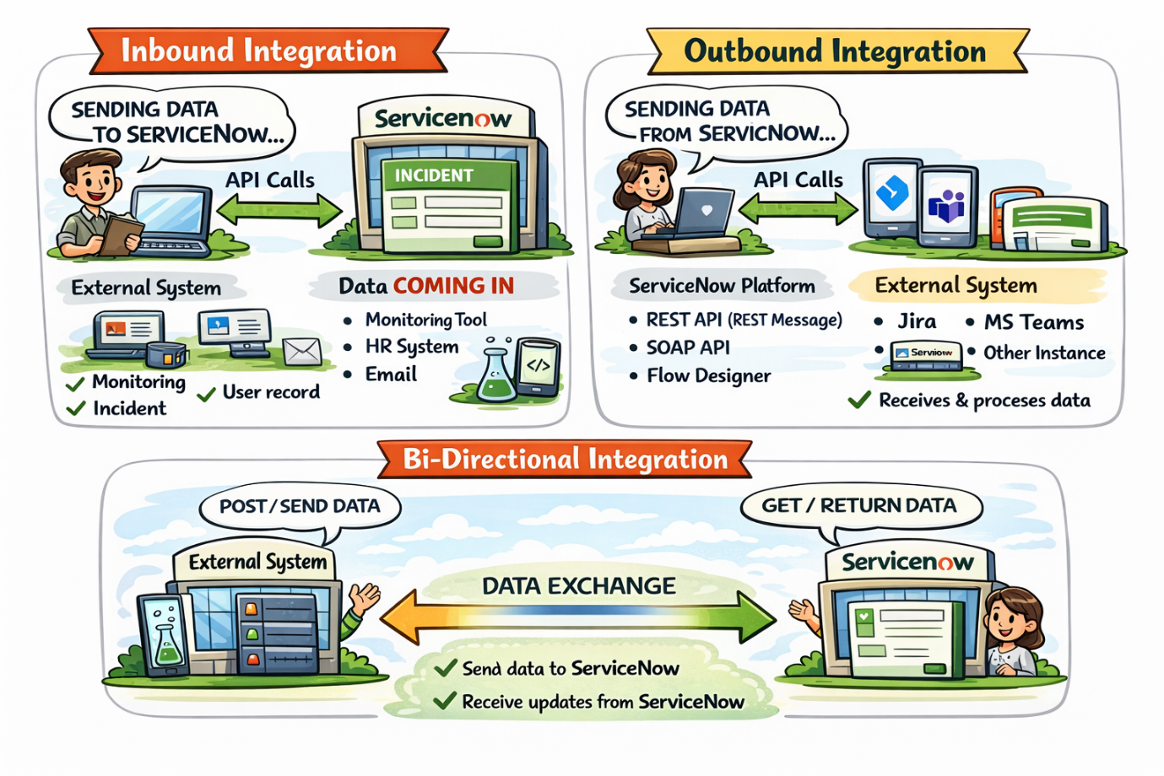

4.⁠ ⁠What is Service Catalog?
Service Catalog is a self-service portal in ServiceNow where users request services or items instead of calling or emailing IT.
👉 Think of it like an online shopping website for IT and business services.

🛒 Simple Analogy
- Amazon / Flipkart → Buy products
- Service Catalog → Request services

🧠 Simple Definition (Interview-Ready)
Service Catalog is a structured list of services and request items that users can order through a self-service portal, and ServiceNow fulfills them using workflows or flows.

🧩 What Users Can Request?
Examples:
- 🖥️ New Laptop
- 📧 Email Access
- 🔐 VPN Access
- 👤 User Account Creation
- 📅 Meeting Room Booking
- 📦 Software Installation

5.⁠ ⁠Difference between Service Catalog and Record Producer?
Service Catalog is used to request services, while a Record Producer is used to create records directly in ServiceNow tables using a catalog-style form.
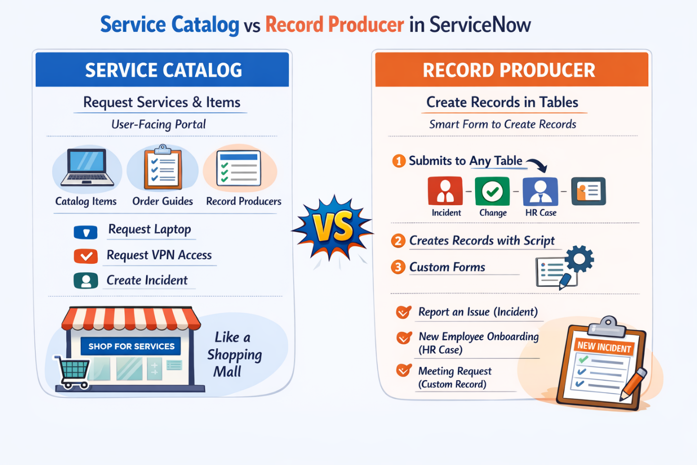
6.⁠ ⁠What is Client Script? What are the types of Client Script? Explain each type of Client Script?
In ServiceNow, a Client Script is used to control the behavior of a form on the client side (browser).
It runs before data is sent to the server, helping improve user experience by validating data, auto-filling fields, showing messages, etc.

What is a Client Script?
A Client Script is a JavaScript that executes in the user’s browser to:
- Validate user input
- Auto-populate or modify field values
- Show / hide / make fields mandatory
- Display messages to users
👉 It does NOT interact directly with the database.

Types of Client Scripts in ServiceNow
There are 5 types of Client Scripts:
Type | When it Runs
onLoad | When the form loads
onChange | When a field value changes
onSubmit | When the form is submitted
onCellEdit | When a list cell is edited
onDisplay | When a form is displayed (read-only)

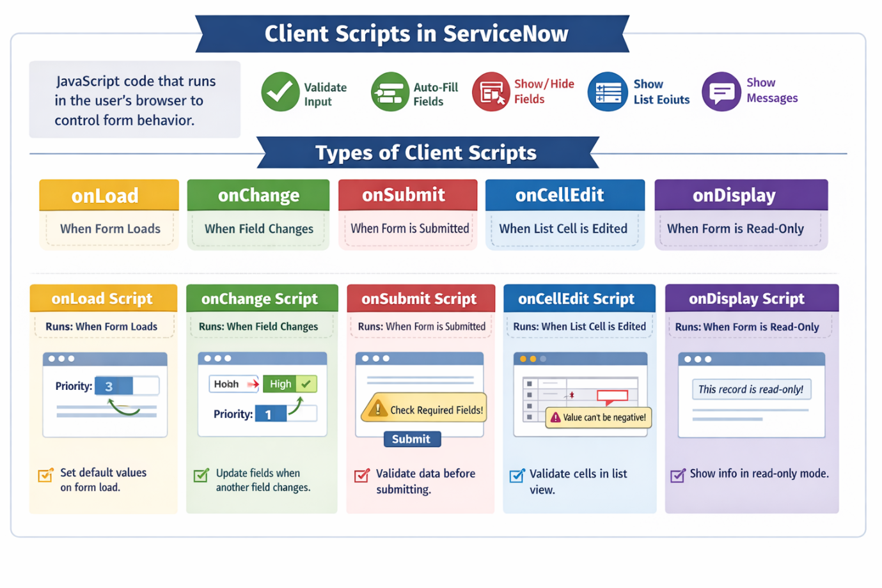
7.⁠ ⁠What is Business Rule? What are its types and when does it run?
A Business Rule is a server-side script in ServiceNow that automatically runs when a record is inserted, updated, deleted, or queried in a table.
It is mainly used to enforce business logic, validate data, or automate actions at the database level.
📌 Business Rules run on the server, not in the browser.

🔹 Types of Business Rules (Based on When They Run)
ServiceNow provides 4 main types of Business Rules:

1️⃣ Before Business Rule
🕒 Runs: Before the record is saved to the database
✅ Use cases:
- Validate data before saving
- Set default values
- Stop a record from being saved
🧠 Example:
- Prevent closing an incident if Resolution Notes are empty
- Auto-set Priority based on Impact & Urgency

2️⃣ After Business Rule
🕒 Runs: After the record is saved to the database
✅ Use cases:
- Trigger follow-up actions
- Update related records
- Send events or notifications
🧠 Example:
- Create a Problem record after an Incident is closed
- Update Task SLA after an update

3️⃣ Async (Asynchronous) Business Rule
🕒 Runs: After commit, in the background
✅ Use cases:
- Long-running tasks
- Performance-heavy operations
🧠 Example:
- Send emails
- Call integrations (REST/SOAP)
- Mass record updates
⚡ Does not slow down the user form save.

4️⃣ Display Business Rule
🕒 Runs: Before the form is displayed to the user
✅ Use cases:
- Control UI behavior
- Set read-only or mandatory fields
- Show/hide fields (server-side)
🧠 Example:
- Make Assigned to read-only if the state is Closed
- Populate scratchpad values

🔹 When Does a Business Rule Run?
Operation | Runs Business Rule?
Insert record | ✅ Yes
Update record | ✅ Yes
Delete record | ✅ Yes
Query record | ✅ Yes (Advanced option)
⏱ Execution depends on:
- When (Before / After / Async / Display)
- Condition
- Order

🔹 Business Rule vs Client Script (Quick Tip)
Business Rule | Client Script
Server-side | Client-side
Secure | Less secure
Runs on DB actions | Runs on form events
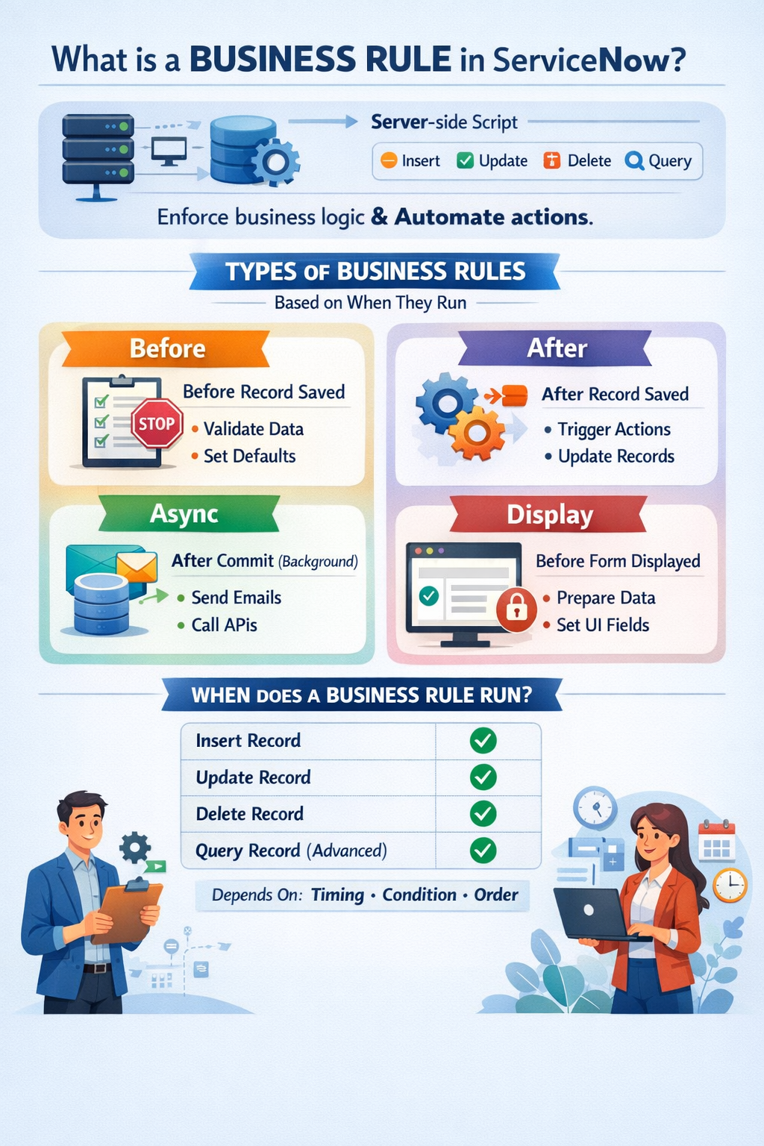

8.⁠ ⁠What is SLA? What are the types of SLAs?
✅ What is an SLA (Service Level Agreement)?
An SLA (Service Level Agreement) is a formal agreement between a service provider (like IT/ServiceNow team) and a customer/business that defines:
- What service will be provided
- Expected response and resolution times
- Performance targets
- Penalties or escalations if targets are not met
👉 In ServiceNow, SLAs are mainly used to track and manage time taken to respond to and resolve records such as Incidents, Requests, Problems, and Changes.

🎯 Why SLAs are Important
- Ensures timely service delivery
- Improves customer satisfaction
- Provides clear expectations
- Helps in performance tracking & reporting

🧩 Types of SLAs in ServiceNow
ServiceNow mainly supports three types of SLAs:

1️⃣ SLA (Service Level Agreement)
🔹 Purpose:
Used for standard IT services where the IT team commits to certain service levels.
🔹 Example:
- Respond to a High Priority Incident within 30 minutes
- Resolve within 4 hours
🔹 Used for:
- Incident
- Problem
- Change
- Service Catalog tasks
📌 Most commonly used SLA

2️⃣ OLA (Operational Level Agreement)
🔹 Purpose:
Agreement between internal teams within the organization.
🔹 Example:
- Network team must resolve issues within 2 hours
- Database team must respond within 1 hour
🔹 Used for:
- Internal coordination
- Supporting teams
📌 Customer does NOT see OLAs

3️⃣ UC (Underpinning Contract)
🔹 Purpose:
Agreement with external vendors or third-party suppliers.
🔹 Example:
- Vendor must fix hardware issue within 8 hours
🔹 Used for:
- Vendor performance tracking
- External service commitments
📌 Supports SLAs & OLAs

📊 SLA Types Summary Table
Type | Agreement Between | Used For
SLA | Service Provider ↔ Customer | Customer-facing services
OLA | Internal Teams | Internal support
UC | Organization ↔ Vendor | External services

🧠 Simple Real-Life Example
Incident Raised by User
- SLA: IT must respond in 30 min
- OLA: Network team fixes in 1 hour
- UC: ISP resolves line issue in 6 hours

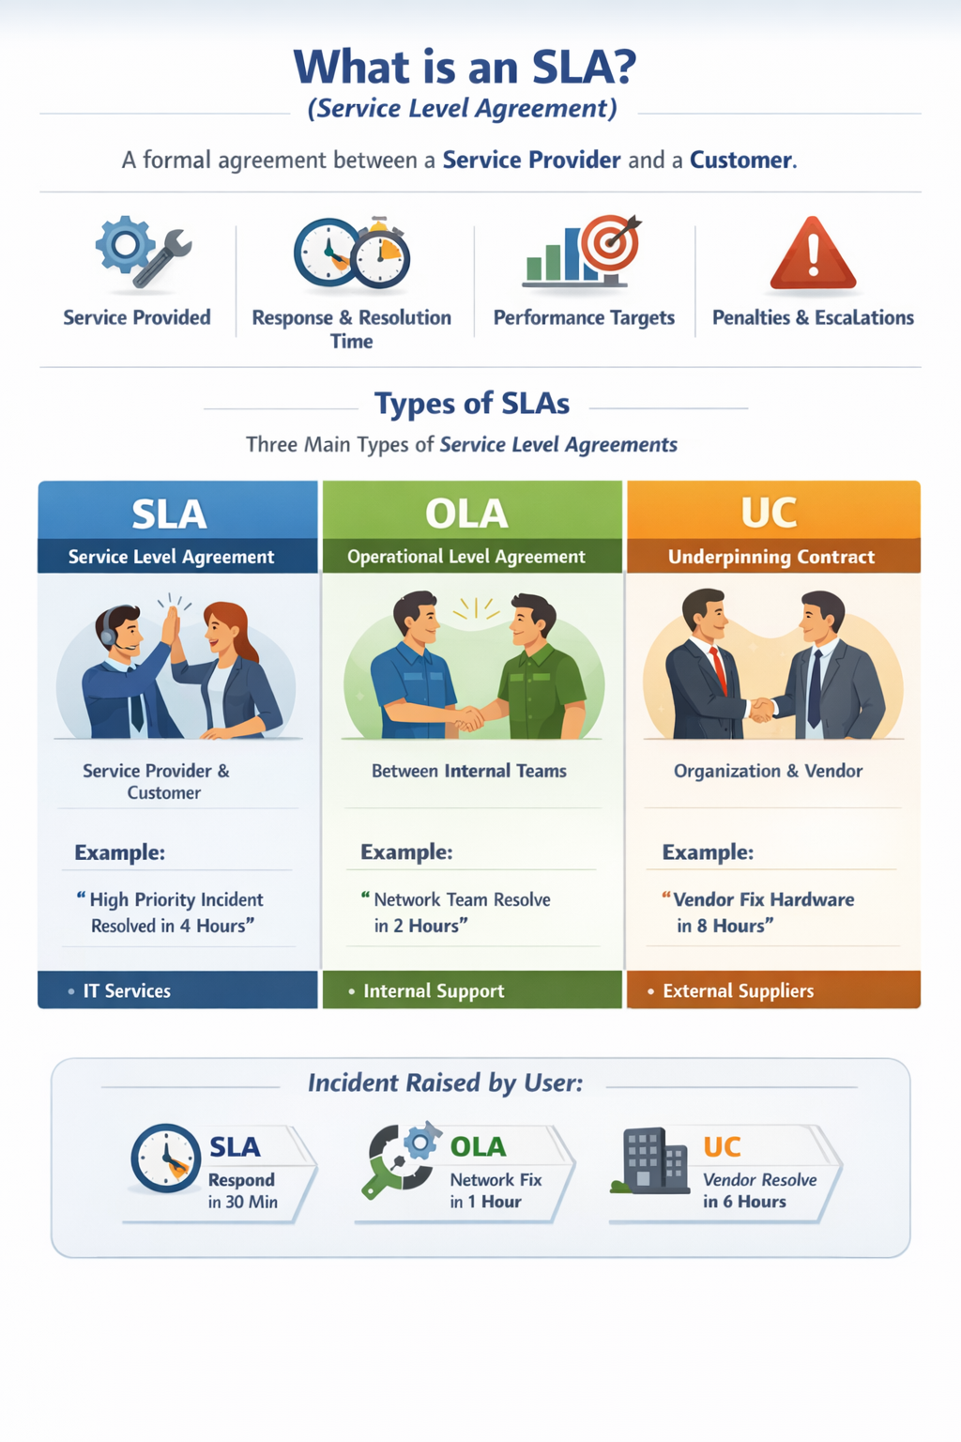
9.⁠ ⁠What is CMDB?
CMDB (Configuration Management Database):
A CMDB is a centralized repository that stores information about an organization’s IT assets (Configuration Items or CIs) and the relationships between them. It acts as a single source of truth for IT infrastructure, helping in asset management, impact analysis, change tracking, risk management, and faster issue resolution.
Key points:
- Stores details of servers, network devices, cloud services, software, and other IT assets.
- Tracks dependencies and relationships between assets.
- Supports impact analysis before changes.
- Improves visibility and control over IT environment.
The image you generated visually shows all of this with assets, relationships, key functions, and benefits.
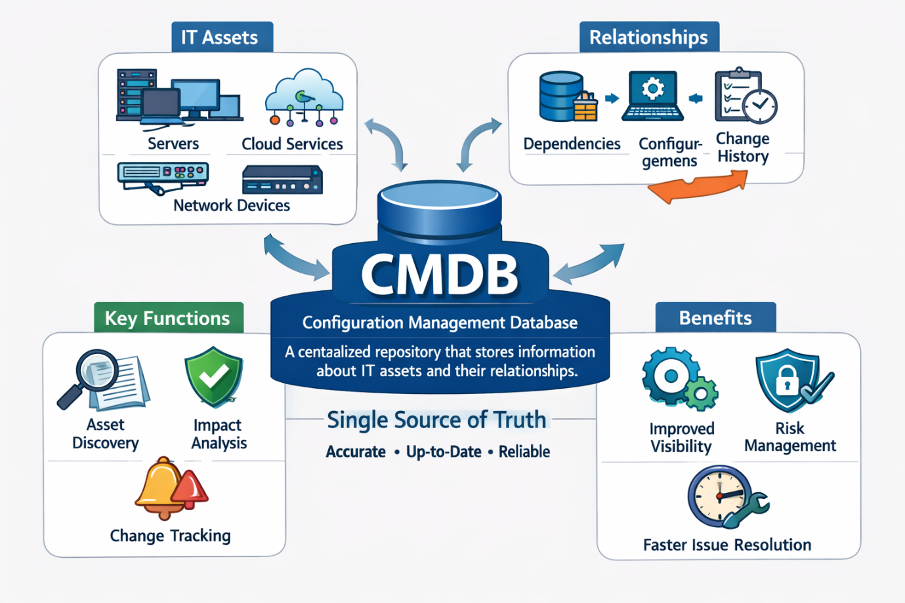
10.⁠ ⁠Difference between Client Script and UI Policy?
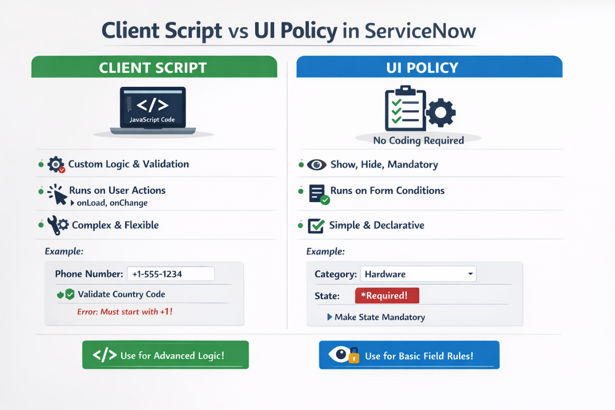
11.⁠ ⁠Order of execution of ACL, Client Script, UI Policy, and Business Rule?
Here’s a clear explanation of the order of execution in ServiceNow for ACLs, Client Scripts, UI Policies, and Business Rules. I’ll break it down step by step and then summarize in a diagram-style flow.

1. Access Control Rules (ACLs)
- When: Before any operation (read, write, create, delete) is allowed on a record or field.
- Purpose: Security check.
- Execution: Server-side, first thing.
If the ACL fails, the operation stops.
✅ Key point: ACLs always run before Business Rules or any database operation.

2. UI Policies
- When: Client-side, when a form loads or a field changes.
- Purpose: Dynamically show/hide, make fields mandatory, or read-only.
- Execution: Happens after the form is loaded, but before the user starts entering data.
- UI Policy actions execute in the browser.

3. Client Scripts
- When: Client-side, triggered on form events:
  - onLoad: Runs after form load.
  - onChange: Runs when a field value changes.
  - onSubmit: Runs before form submission.
  - onCellEdit: Runs when editing a list.
- Purpose: Custom client-side logic.
- Execution order on a form:
  - onLoad → after form loads and UI Policies are applied.
  - onChange → after a field changes.
  - onSubmit → before the form is sent to the server.

4. Business Rules
- When: Server-side, when database operations occur.
- Types & Execution:
  - Before → Before insert/update/delete on database.
(Can modify record before saving)
  - After → After insert/update/delete on database.
(Good for logging, notifications)
  - Async → Runs in the background after operation.
  - Display → Runs before form load, can set values for display.
- Execution: Happens after ACLs are passed but before/after DB commit depending on type.

🔹 Simplified Execution Flow
Step | Execution Location | Trigger/Type | Notes
1 | Server | ACLs | Security check first; can block access
2 | Server | Business Rule (Before) | Modify record before save
3 | Client | UI Policy | Show/hide/mandatory/read-only fields
4 | Client | Client Script (onLoad) | Custom client logic on form load
5 | Client | Client Script (onChange) | Custom logic on field change
6 | Client → Server | Form Submit | Client Script onSubmit runs
7 | Server | Business Rule (After) | Actions after DB save
8 | Server | Business Rule (Async) | Background processing

💡 Key Notes:
- ACLs always first to ensure security.
- UI Policies run before client scripts on load.
- Client Scripts can run after UI policies and handle dynamic client behavior.
- Business Rules run on the server, either before or after DB operations.
- 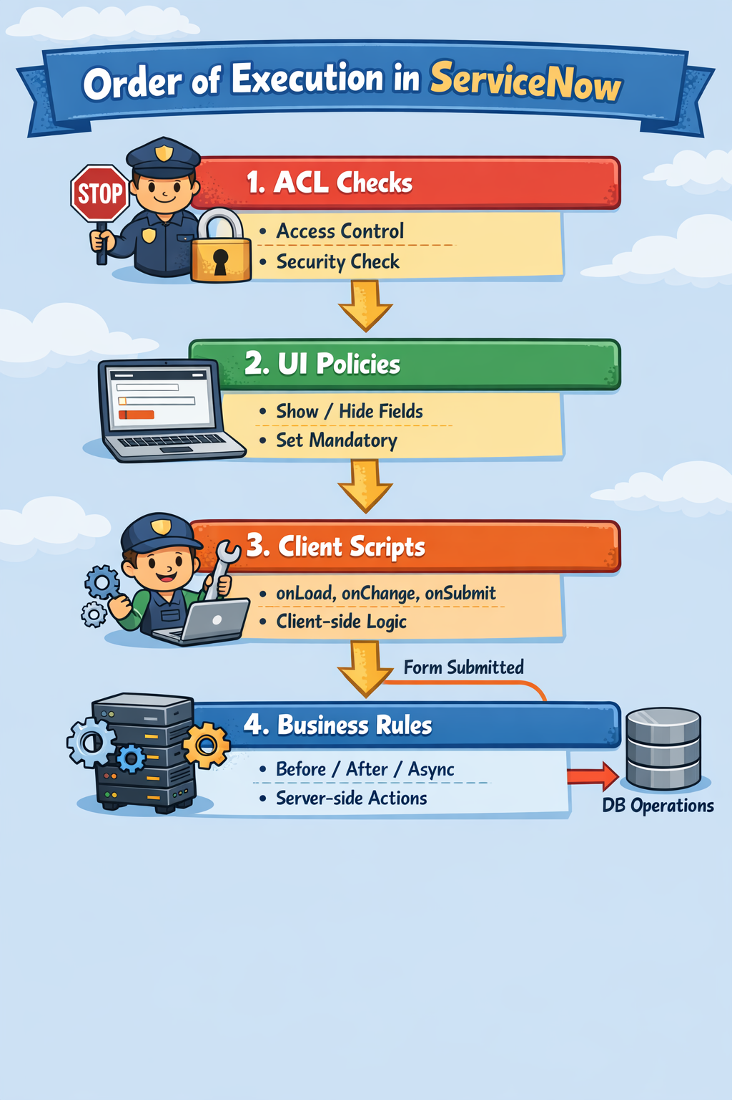

12.⁠ ⁠How do you move a record from Dev to Test?
In ServiceNow, record transfer between instances (Dev → Test → Prod or any instance → another) depends on what you are transferring:
- Configuration (metadata) → use Update Sets
- Data (table records) → use Import / Export, Transform Maps, or APIs
- 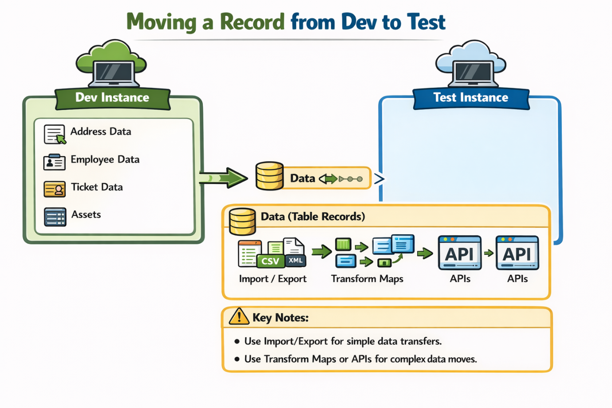

13.⁠ ⁠What is Retroactive Start in SLA?
In ServiceNow, Retroactive Start is a concept used in SLAs (Service Level Agreements) to handle situations where an SLA should have started earlier than the actual record creation or triggering event.
Here’s a detailed explanation:

Definition
Retroactive Start allows an SLA to calculate its timer based on a past date/time instead of starting from the moment the SLA is attached to a record. This is useful when you want to track SLA compliance for work that was already in progress before the SLA was created or applied.

How it Works
- Normally, an SLA starts when the conditions in the SLA definition are first met.
- If Retroactive Start is enabled, you can specify a field on the record that contains a past date/time. The SLA will start from that timestamp instead of the current time.
- This ensures that SLA calculations are accurate even if the record is old or if the SLA was applied later.

Example
- Incident INC001 was created at Dec 31, 10:00 AM.
- SLA is applied at Dec 31, 2:00 PM.
- The SLA has a Retroactive Start field pointing to Opened At date.
- SLA start time will be Dec 31, 10:00 AM, not 2:00 PM.
- SLA compliance will now measure from the original incident creation time.

Key Points
- Helps in backdating SLA tracking.
- Ensures accurate reporting for historical data.

14.⁠ ⁠What is a Transform Map and why do we use it?
In ServiceNow, a Transform Map is a configuration that defines how data from an imported source (like an Excel, CSV, or external database) is mapped to ServiceNow tables. Essentially, it tells ServiceNow how to take raw data and put it into the right fields in your target table.
We use it because when importing data, the field names and formats in the source may not match the target table, so we need a mapping to transform the data correctly.

Key Points:
- Source Table: The table where imported data temporarily resides (usually import_set table).
- Target Table: The ServiceNow table where data will ultimately be stored (e.g., Incident, User).
- Field Mapping: Each column in the source can be mapped to a field in the target. You can also apply transform scripts to manipulate data during import.
- Coalesce Field: Determines a unique key to avoid duplicate records. If a matching record exists based on the coalesce field, ServiceNow will update it instead of creating a new record.

Why We Use Transform Maps:
- To move data from external sources into ServiceNow systematically.
- To standardize and clean data while importing.
- To prevent duplicate records by using coalesce fields.
- To automate large imports instead of manual entry.

Example Scenario:
You have an Excel sheet with users:
First Name | Last Name | Email | Dept
John | Doe | john@abc.com | IT
Jane | Smith | jane@abc.com | HR
You want to import this into the User table (sys_user).
- First Name → first_name
- Last Name → last_name
- Email → email (and use as coalesce to avoid duplicates)
- Dept → department
The Transform Map handles all this mapping automatically.

15.⁠ ⁠Difference between UI Policy and Data Policy?
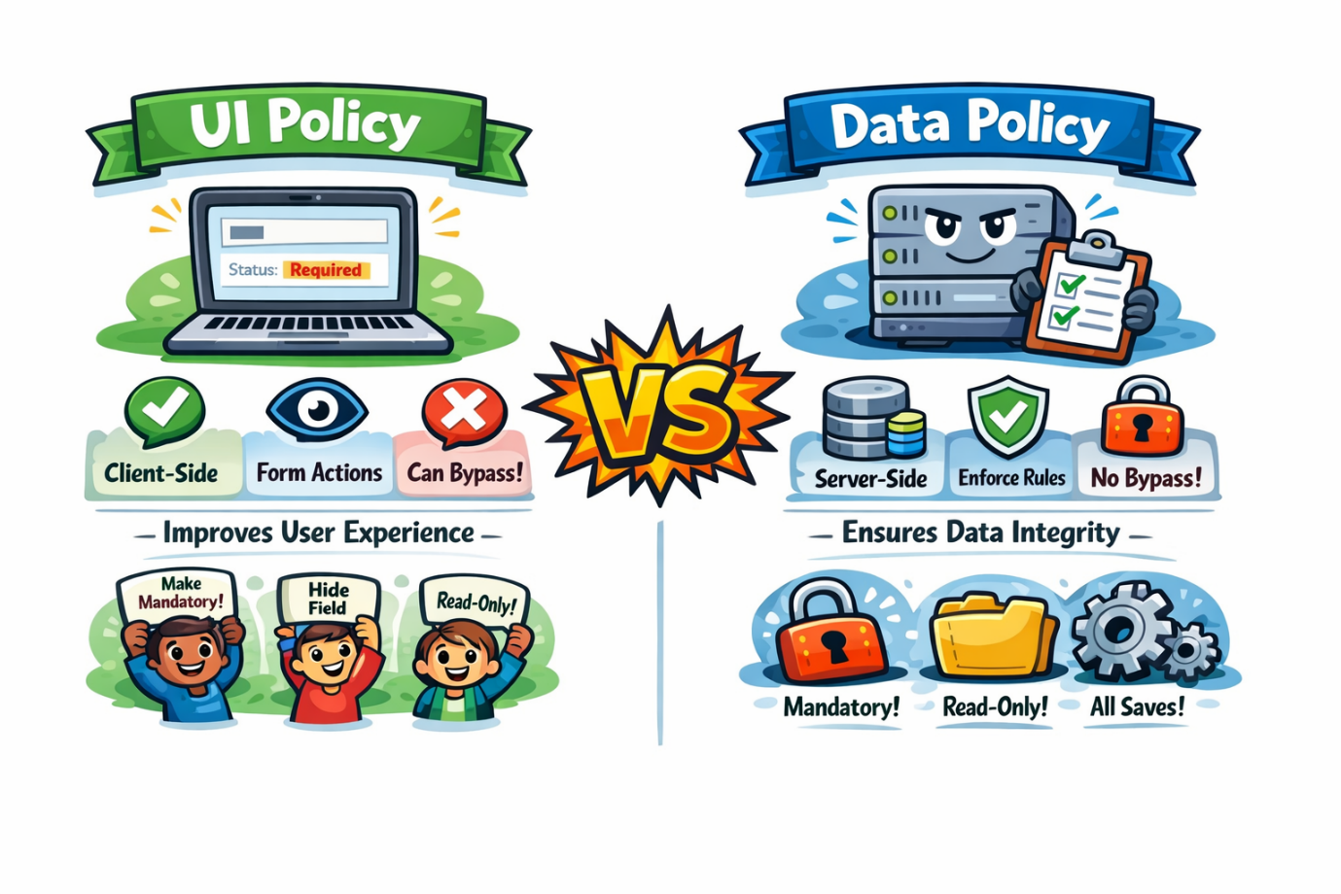
16.⁠ ⁠What is a Notification and why do we use it?
A Notification in ServiceNow is a message or alert that is automatically sent to users or groups when certain conditions are met in the system. These messages can be sent via email, SMS, push notification, or in-platform messages.
In simple terms, it’s how the system informs people about important events or updates.

Why Do We Use Notifications?
Notifications are used to:
- Keep Users Informed – Alert users about important events, such as incidents being assigned, approvals pending, or SLA breaches.
- Automate Communication – Avoid manual emails by sending automated messages based on triggers.
- Improve Response Times – Ensure users get real-time updates, helping them act faster.
- Ensure Accountability – Track who received which message and when, which is critical for IT processes.
- Enhance User Experience – Users get relevant information without having to constantly check the system.

Key Components of a Notification
- Trigger Condition – Event or change that causes the notification (e.g., incident assignment).
- Recipients – Users, groups, or roles who should receive the notification.
- Message Content – Text, variables, or templates defining the information to send.
- Delivery Method – Email, SMS, push notifications, etc.

17.⁠ ⁠What is a Workflow?
A Workflow in ServiceNow is a visual representation of a business process that automates the sequence of activities and tasks in the system. It defines how work moves from one step to another automatically without manual intervention.
Think of it as a flowchart where each step represents an action, approval, or decision in a process.

Why Do We Use Workflows?
Workflows are used to:
- Automate Business Processes – Instead of manually assigning tasks or sending notifications, workflows handle it automatically.
- Ensure Consistency – Every process follows the same steps in the same order, reducing errors.
- Improve Efficiency – Speeds up task completion and reduces repetitive work.
- Track Progress – Provides visibility into the status of tasks and approvals.
- Integrate Activities – Connects tasks, approvals, notifications, and scripts into a single process.

Key Components of a Workflow
- Activities – Actions that happen in the workflow, like creating tasks, sending notifications, or approvals.
- Transitions – Define how and when the workflow moves from one activity to the next.
- Conditions – Rules that determine whether an activity should run.
- Triggers – Events that start the workflow, such as a new incident or request submission.
- Workflow Editor – A graphical tool in ServiceNow to design and visualize workflows.

18.⁠ ⁠What is a UI Action? What are the types of UI Actions?
A UI Action in ServiceNow is a button, link, or context menu option that performs an action when clicked by a user. It is used to execute scripts, navigate to other pages, or trigger processes on forms or lists. Essentially, UI Actions allow users to interact with records and perform tasks directly from the UI.

Key Points About UI Actions
- Can be shown as a button, link, or context menu item.
- Can execute client-side scripts, server-side scripts, or both.
- Can be conditional, meaning it shows only under certain circumstances.
- Can run before or after a record is saved, depending on configuration.

Types of UI Actions
UI Actions can be categorized based on where they appear and how they behave:
- Form Buttons
  - Appear on a form header or form section.
  - Example: Save, Submit, Approve.
  - Can be used to save the record or perform custom actions.
- Form Links
  - Appear as links on forms, usually in the form header.
  - Example: Show Related Records.
- List Buttons
  - Appear on list views above the list or in the context menu.
  - Example: Export, New, Delete Selected.
- List Context Menu
  - Appear when you right-click on a record in a list.
  - Example: Assign to Me, View History.
- UI Action Types by Execution
  - Client-side UI Action – runs in the user’s browser using client scripts.
  - Server-side UI Action – runs on the server using GlideRecord or server scripts.
  - Both Client & Server – can call a server-side script from a client script.

💡 Example:
If you want a button called “Resolve Incident” on the Incident form that automatically updates the status to Resolved:
- Type: Form Button
- Client Script: Optional (maybe to show a confirmation popup)
- Server Script: Update the incident record status

19.⁠ ⁠What is the order of execution of Business Rules?
In ServiceNow, the order of execution of Business Rules (BRs) depends on the type of Business Rule (before, after, async, or display) and their order number. Let’s break it down carefully:

1. Types of Business Rules
- Before – Runs before the database operation (insert, update, delete, query).
- After – Runs after the database operation.
- Async – Runs after the database operation, but asynchronously (not in real-time, runs in the background).
- Display – Runs before data is displayed on a form, mainly for modifying g_scratchpad or setting field values.

2. Execution Order
A. Before Business Rules
- Triggered before the record is saved.
- Execution order is determined by the Order field (ascending).
  - Example: Order = 100 runs before Order = 200.
B. After Business Rules
- Triggered after the record is saved.
- Also follows the Order field (ascending).
C. Async Business Rules
- Triggered after the database operation, runs asynchronously in a separate thread.
- Order of execution is not guaranteed, so they should not depend on each other.
D. Display Business Rules
- Triggered before the record loads on a form.
- Can set values in g_scratchpad to be used in client scripts.

20.⁠ ⁠Scenario: If you need to make a field mandatory, which would you use UI Policy, Client Script or Dictionary? Why?
Let’s break this down carefully. You asked which one to use to make a field mandatory in ServiceNow and why. Here’s a clear comparison:

1️⃣ Dictionary Level (Field Definition)
- How it works: You can mark a field as mandatory directly in the table dictionary (Mandatory checkbox).
- Scope: Applies everywhere—UI, API, imports, and scripts.
- Pros:
  - Enforces mandatory at the database level.
  - Cannot be bypassed by users.
- Cons:
  - Not flexible for conditional requirements (e.g., “mandatory only if state = ‘Closed’”).
- Use case: When a field is always required, no matter what form or conditions.

2️⃣ UI Policy
- How it works: Makes fields mandatory dynamically on forms based on conditions.
- Scope: Only works on the UI (forms).
- Pros:
  - Can make a field mandatory conditionally (e.g., only if another field has a certain value).
  - Easy to maintain and configure (no coding needed).
- Cons:
  - Only affects the UI, not backend scripts or imports.
- Use case: When a field is conditionally mandatory in the UI.

3️⃣ Client Script
- How it works: Uses scripts (usually onChange or onLoad) to make fields mandatory dynamically.
- Scope: Only on the UI.
- Pros:
  - Can handle very complex conditions.
- Cons:
  - Requires coding.
  - UI-only, so server-side actions (like API inserts) won’t be affected.
- Use case: When the mandatory logic is too complex for a UI Policy.

✅ Best Practice
- Always prefer UI Policy for making a field mandatory on the form, because it’s declarative, easier to maintain, and doesn’t require coding.
- Use Dictionary if the field must be mandatory everywhere, even in backend operations.
- Use Client Script only for complex conditions that cannot be handled by UI Policy.

Summary Table:
Method | Mandatory Everywhere? | Conditional? | Coding Required? | Best Use Case
Dictionary | ✅ Yes | ❌ No | ❌ No | Always required fields
UI Policy | ❌ No | ✅ Yes | ❌ No | Conditional mandatory in forms
Client Script | ❌ No | ✅ Yes | ✅ Yes | Complex conditions beyond UI Policy

21.⁠ ⁠Scenario: If a field is set to read-only using a Client Script and the same field is set to editable using a UI Policy, what will happen?
Ah! This is a classic ServiceNow field behavior conflict scenario. Let’s analyze carefully.

Scenario:
- Field X is set to read-only via a Client Script.
- Same field X is set to editable via a UI Policy.
You want to know: what actually happens on the form?

Key Points:
- Client Script (onLoad / onChange / onSubmit):
  - Runs after the form loads (onLoad/onChange) or when specific events occur.
  - If a Client Script sets a field to read-only, it will override other settings unless another script changes it afterward.
- UI Policy:
  - Can make fields mandatory, visible, or read-only.
  - Runs automatically after the form loads.
  - UI Policy’s read-only/mandatory logic has a higher priority than manual scripting in many cases, but it depends on execution order.

Execution Order:
- onLoad Client Scripts run before UI Policies.
- UI Policies are applied after the form is rendered, so they usually override Client Script changes made onLoad.
Exception:
- If the Client Script is onChange and runs after the UI Policy is applied, it may reset the field to read-only, causing conflict.

✅ Typical Outcome:
- If both are onLoad:
  - UI Policy wins, so the field becomes editable.
- If the Client Script runs after the UI Policy (e.g., onChange or async):
  - The field will become read-only, overriding the UI Policy.

🔹 Rule of Thumb:
UI Policies and Client Scripts can conflict. The last executed script determines the field behavior.
Best practice: don’t mix read-only logic in Client Scripts and UI Policies for the same field.

22.⁠ ⁠Scenario: If you need to move a record from Dev to Test, how would you achieve this?
In ServiceNow, record transfer between instances (Dev → Test → Prod or any instance → another) depends on what you are transferring:
- Configuration (metadata) → use Update Sets
- Data (table records) → use Import / Export, Transform Maps, or APIs
✅ Method 1: Export / Import (Small Data)
Best for: Few records, one-time transfer
Steps:
- Source Instance
  - Open list view of table
  - Right-click header → Export
  - Choose CSV / Excel / XML
- Target Instance
  - Go to System Import Sets → Load Data
  - Upload file
  - Create Transform Map
  - Transform data into target table
✔ Easy
❌ Not ideal for large datasets or automation

✅ Method 2: Import Set + Transform Map (Recommended)
Best for: Structured, repeatable data transfer
Steps:
- Export data from source (CSV / Excel)
- Load file into target instance
- Create Transform Map
  - Map source → target fields
  - Use Transform Scripts if needed
- Run Transform
✔ Controlled
✔ Supports scripts & validation
✔ Best practice for data migration

✅ Method 3: Web Services (REST API) ⭐ BEST FOR AUTOMATION
Best for: Real-time or bulk transfer between instances
High-level flow:
- Source Instance → Script / Scheduled Job
- Uses REST Message
- Sends records to Target Instance
- Target Instance → Scripted REST API
- Inserts / updates records
Example (Source Instance – REST Message Script):
var rm = new sn_ws.RESTMessageV2();
rm.setEndpoint('https://target_instance.service-now.com/api/now/table/u_meeting');
rm.setHttpMethod('POST');
rm.setBasicAuth('admin', 'password');
rm.setRequestHeader("Content-Type", "application/json");

var body = {
short_description: "Weekly Review",
state: "scheduled"
};

rm.setRequestBody(JSON.stringify(body));
var response = rm.execute();
✔ Automated
✔ Secure
✔ Best for Prod-safe integrations

🔹 3️⃣ Transfer Users / Groups
✅ Use:
- LDAP / AD Sync (Best)
- Import Set (CSV)
- REST API
❌ Avoid Update Sets

🔹 4️⃣ What Method Should YOU Use? (Quick Decision Table)
What to Transfer | Recommended Method
Tables / Fields | Update Set
Business Rules / Scripts | Update Set
Meeting Records | Import Set / REST API
Users | LDAP / Import
Large Data | Import Set / REST
Automated Sync | REST API

🔹 5️⃣ Best Practices (VERY IMPORTANT)
✔ Always move Dev → Test → Prod
✔ Preview Update Sets before commit
✔ Never move data using Update Sets
✔ Mask sensitive data
✔ Use naming conventions
✔ Test transform maps in sub-prod

